

**ONLINE AUCTION SYSTEM**

**THESIS SUBMITTED IN PARTIAL FULFILMENT OF THE**

**REQUIREMENT FOR DIPLOMA IN IT**

**BY**

**KOTOINE NASERIAN JULIET**

**TO**

**THE DEPARTMENT OF INFORMATION TECHNOLOGY**

**FACULTY OF SCIENCE AND ENGINEERING**

**ZETECH UNIVERSITY**

**JANUARY 2022**

**DECLARATION**

i hereby declare that the project work entitled ONLINE AUCTION SYSTEM is my work and the record of my own work.

I further declare that no part of this project is copied from or transfered from any source.

NAME:

ADM NO:

DATE:

**DEDICATION**

We dedicate this work to the Almighty God who has given us the wisdom, great fortune in our

education and opportunity to do this Research Project oriented work. We thank our dearest

parents and business partners for their endless support, by being there for us at all times.-

especially om· parents.

**ACKNOWLEDGEMENT**

Firstly, I would like to thank the almighty God for His protection during the entire work. I also acknowledge the entire school and my supervisor for his guide during the project.

I express my sincere gratitude to the university HOD MR Daniael Njeru for providing an opportunity to work on a real time project.

I would also thank my parents for their continous support that plays an important role in the completion of this project.

**ABSTRACT**

An online auction system is a system that does the process of selling,buying and services offered at a place. This is a system where we participate in a bid of products and services selling online. What the system does is it offers quality products and services by advertising its products and customers inquiring can readily order the service or product through us in a quicker possible way. One doesn’t have to walk and buy services the system goal is to ensure services and products are readily available for bidders and they doesn’t have to walk and buy but all they do is bid for our services,

The scope of the system is to take the auctioning system to a worldwide platform where everyone can bid for the products anywhere nomatter the distance.

Aim of the system is to provide a user friendly platfrom where users can effieciently bid for products,to provide a user validation and checking instances for consistency.

**TABLE OF CONTENTS**

**DECLARATION** i

**ACKNOWLEDGEMENT** ii

**DEFINITION OF KEY TERMS** iii

**ABBREVIATIONS AND ACRONYMS** iv

**ABSTRACT** v

**LIST OF FIGURES** vi

**LIST OF TABLES** vii

**CHAPTER ONE: RESEARCH INTRODUCTION** 1

**1.1** **Executive Summary** 1

**1.2** **Research Objectives** 1

**1.2.1** **General Objective** 1

**1.2.2** **Specific Objectives** 1

**1.3** **Background Information** 1

**1.4** **Study Justification** 1

**1.5** **Study Limitation** 1

**1.6** **Problem Scope** 1

**CHAPTER TWO: LITERATURE REVIEW** 2

**2.1 Introduction** 2

**2.2 Global Review** 2

**2.3 Regional Review** 2

**2.4 Local Review** 2

**CHAPTER THREE: SYSTEM METHODOLOGY AND DATA COLLECTION** 3

**3.1 Introduction** 3

**3.2 System Requirements Specification** 3

**3.2.1 Functional Requirements** 3

**3.2.2 Non Functional Requirements** 3

**3.3. Design** 3

**3.3.1 Low Level Design** 3

**3.3.2 High Level Design** 3

**3.4 Implementation / Development** 3

**3.4.1 Language(s), Frameworks and Other Technical Requirements** 3

**3.4.2 Code Review Strategy** 3

**3.5 Testing** 4

**3.5.1 Functional Requirements Testing** 4

**3.5.2 Non-Functional Requirements Testing** 4

**3.6 Deployment** 4

**CHAPTER FOUR: CONCLUSION AND RECOMMENDATIONS** 5

**4.1 CONCLUSION** 5

**4.2 RECOMMENDATIONS** 5

**CHAPTER FIVE: REFERENCES AND APPENDICES** 6

**5.1 REFERENCES** 6

**5.2 APPENDIX I:** 6

**5.3 APPENDIX II:** 6

**5.4 APPENDIX III: GANTT CHART** 6

**CHAPTER ONE**

**INTRODUCTION**

**1.0 Introduction**

This chapter covers the background of the project, the statement of the problem, objectives, the

scope and the significances of the project.

* 1. **executive summary**

online auction system is a web-based application which help users to buy ar sell item; they can trade anaything they want by posting ad. This application will allow users to post their products for auction;bidder can register and can bid for any available product. There are some existing applications that allow users for bidding but the product is not available in your local area, you cannot do inspection of the product that you are going to buy. By the online auction system users will be able to bid for the product that is available in the area.

* 1. **research objectives**

**1.2.1. generic objectives**

To develop an online auction system that will provide a forum for sellers to meet an dinteract with buyers and sells items to the intersted bidders.

**1.2.2. specific objectives**

* To implement and test the workability of the newly system.
* Create a panel where the sellers receives requests from buyer and sends back a feedback and an answer to questions.
* Create an online forum where bidders auction for items posted by the seller through the online system.

**1.3 background of information**

The internet has become a very important aspect of life today. People spend alot of time seeking to buy items.

It is open that most people are seeking to buy items everday in most cities and towns, both locally and abroad,desperate if they might get a solution or a right person to deliver a solution to them.

This project shall handle the issue by creating an online platform where a user will be able to post items onlinefoe auction.the items will accompany item name,selling price and a picture presentation for the bidder to see. If the bidder is interested in the item, will auction for the product and will be to inspect the item physically to approve the product then compete the business with the seller.

It is important since the auctioneer does not necessarily need to make a physical consultation with the seller for him/her to get the required services. The auctioneer will have a provision to chat with the seller and consult him the details of the product.

The system is a forum where the bidders meet their respective prodcut sellers in their locality on the internet to solve the problem of auctioning

* 1. **study justification**

To develop an online auction system which will provide forum for the sellers and buyers the forum will accomplish the following as a way of achieving the major goal:

* To build a friendly auctioning website where the user will be able to auction any product which is available nearby or anwhere in the world.
* To implement and test the workability of the newly developed system.
  1. **study limitation**

1. Wrong constraint specification.
2. Wrong data input from technical user
3. Incomplete data from data collection
   1. **problem scope**

The search for items has always been a mind-chewing activity to most people in country and in the whole globe. People are always on the go to their renown product supplier or nearby market center or at times a local hawkers who go supply for items the buyers wants mostly they give their hands to get them items and at times they mess and bring fake and deliver bad items.this is beacuse unqualified people offer delivery items to customers.

**CHAPTER TWO: LITERATURE REVIEW**

**2.1 Existing online auction system**

The first part of the project is an investigation of already existing on-line auction systems

around the net. We considered three of the most famous auction web sites: eBay.com,

asteinrete.com and onsale.com.

The table below describes the functionality offered to the users by this three big auction

systems:

|  |  |  |  |
| --- | --- | --- | --- |
| **User Stories** | **eBay.com** | **Asteinrete.com** | **Onsale.com** |
| Home page | **x** | **x** | **x** |
| registration | **x** | **x** | **x** |
| **login** | **x** | **x** | **x** |
| **Personal page** | **x** | **x** | **x** |
| **Search** | **x** | **x** | **x** |
| * **Excluding a word** | **x** | **x** |  |
| * **In a given category** | **x** | **x** | **x** |
| * **In a given city** | **x** |  |  |
| * **Having price** | **x** |  | **x** |
| **browse** | **x** | **x** | **x** |
| **Item page** | **x** | **x** | **x** |
| **bid** | **x** | **x** | **x** |
| **Post an auction** | **x** | **x** | **x** |
| **Change language** |  |  |  |
| **help** | **x** | **x** | **x** |
| **administsration** | **?** | **?** | **x** |
| **chat** | **x** |  |  |

As shown in the table, all the three systems give the possibility to register, to login to the

website and have a home page with a general description of the portal. They offer also a

personal page, where each user can check the status of their auctions or of their offers.

Another characteristic of this portals is to have an item page, a page that describes each

item on auction (with a textual description, a photo etc.).

The search functionality is also very important: in addiction to a normal keyword search,

eBay offers also the possibility to search excluding a given word, search in a given

category, search for auctions regarding a given city and to make price range (from € to €)

search.

All the three systems give also the possibility to place a bid, to post an auction and have

also some help pages that explains the aims of the portals and the functionality. None of the portals has the possibility to change language (onsale.com is in English,

asteinrete.com is in Italian while eBay.com is in English but there is also the Italian

version at eBay.it) and only eBay.com has a chat room for the users.

**2.2 Three-tier architecture**

For the realization of the on line auction system we used a 3-tier system architecture as

shown on this schema.

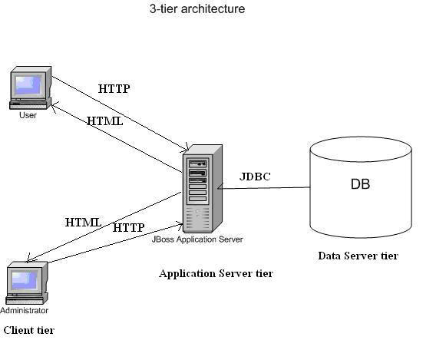

In such architecture, there are 3 main elements:

• The **client tier**, that is responsible for the presentation of data, receiving user

elements and controlling the user interface.

• The **application server tier**, that is responsible for the business logic of the

system. In fact, business-objects that implement the business rules "live" here, and

are available to the client-tier. This tier protects the data from direct access by the

clients. For the project, we used JBoss as application server.

• The **data server** tier, that is responsible for data storage. As data server, we used

PostgreSQL, an open-source relational database.

**2.3 JBoss and EJB**

JBoss is a free, open source, application server that implements the complete Java 2

Enterprise Edition (J2EE) stack, including Java Server Pages (JSP), servlets and

Enterprise JavaBeans (EJB).

For the realization of the project we used the EJB technology, that provides an

architecture for building distributed, component-based, enterprise-level J2EE

applications.

EJB architecture handles the complexity of lower level services, such as component life

cycle, state management, persistence, multithreading, connection pooling, transaction

management and security.

EJB components, called enterprise beans, are scalable, transactional and secure. An EJB

is made up of four parts:

• An **home interface**, that provides methods that control EJB lifecycle operations.

• A **component interface**, that defines the business methods exposed to EJB

clients.

• The **bean implementation**, that contains the methods that perform business logic.

• A **deployment descriptor**, that specifies the declarative semantics that describe

an EJB and the services it requires.

Moreover, there are two types of EJB: session beans, that are used to represent

oprerations on persistent data but not the data, and entity beans that represent persistent

data (usually records in a database).

The persistence of the entity beans is managed in two ways:

• **CMP** (container managed persistence) in which the Container uses the

information in the deployment descriptor to automatically manage the mapping of

EJB to a storage system reducing the amount of code in the bean.

• **BMP** (bean managed persistence) in which the Bean manages the mapping

directly, usually with some JDBC code.

For the realization of this project, we used the CMP management technique.

**2.4 Database and JDBC**

As database for the project we used PostgreSQL, that is an open-source relational

database. A relational database is a type of database management system (DBMS) that

stores data in the form of related tables. Relational databases are powerful because they

require few assumptions about how data is related or how it will be extracted from the

database. As a result, the same database can be viewed in many different ways.

PostgreSQL.

The main difference between these three systems is that MySQL and PostgreSQL are

open source while Oracle is not. Oracle offers more advanced functionality than the other

two systems: it is the fastest, supports transactions (sets of basic operations considered as

single operations) and has enterprise-level data protection and distribution capabilities,

such as full-scale clustered replication. On the other hand, of all open-source database

solutions available, PostgreSQL is the most impressively complete, boasting transaction

support, ANSI SQL92 compliance, a query optimizer and essential data integrity controls

etc.. As database system for the on-line auction portal we choose PostreSQL: it has

not support to fault tolerant installations, but, in our environment and for our needs, there

are no disadvantages in using it.

JBoss can “communicate” with the data server tier using the JDBC API that is the

industry standard for database-independent connectivity between the Java programming

language and a wide range of database. In fact, the JDBC API provides a call-level API

for SQL-based database access and makes possible to do three things:

• Establish a connection with a database or access any tabular data source.

• Send SQL statements.

• Process the results [12].

**2.5 JSP**

For the realization of the web pages of the on-line auction portal, we used the JSP (Java

Server Pages) technology, which is also implemented by the JBoss application server.

JSPs allow developers to combine HTML and Java code in the same document using

special tags that identify Java code.

JSP applies no restrictions to the Java language and its development is very simple. In

fact, JSP pages are simply HTML pages with special tags including Java code performing

elaborations and providing HTML code to be included into the page.

The first execution of a JSP includes three steps:

• Translation of the JSP code into a JavaServlet

• Compilation of the Servlet

• Execution of the Servlet.

The following executions include only the last step. Moreover, it is possible to pre

compile all JSP in order to reduce the time required by the first execution [12].

**2.6 Eclipse and MyEclipse**

For the programming part of the project we used Eclipse, that is a very powerful open

source integrated development environment (IDE). This IDE offers several services to the

developer: it has compiler aware editing; syntax errors are highlighted when they are

made, as are simple semantic errors such as missing declarations. Eclipse supports

method completion, shows class interfaces concisely in graphical notation and supports

interactive exploration of a program, through features such as fly-over name resolution.

In addition, Eclipse supports Software Engineering principles such as packaging,

debugging, testing, refactoring and versioning .

Another very important advantage of using Eclipse is that several plug-ins can be installed on it, like MyEclipse, that is particularly useful when working with Enterprise JavaBeans.

In fact, MyEclipse offers affordable tools for Java and J2EE (Java 2 Enterprise Edition)

developers. Features include:

• Web development tools, such as editors with code completion and syntax coloring

for JSP, HTML, XML and CSS. They include also JSP syntax validation and

native JSP debugging.

• Productivity wizards, such as EJB wizards, archive based deployment (EAR and

WAR) and Sync-On Demand automated deployment of applications to integrated

servers.

• Application Server integration, including integrated controls for starting and

stopping application servers and full hot swap debugging support for deployed

Applications.

**CHAPTER THREE:SYSTEN METHODOLOGY AND DATA COLLECTION**

* 1. **Introduction**

the chapter outlined the methodology that was used in conducting the research. The chapter presented the research design, target population and sampling techniques that were employed. It further identified the data collection instruments that were employed in the research and the procedures for data collection. It concluded by describing how data analysis was conducted and the output.

* 1. **System requirement specifications**

**External interface requirements**

The application ought to be web based.

System feature should be improved for better exection.

**User interface requirement**

A simple graphical user interface(GUI) for easy navigation through the program.

Easy to update profiles and items.

Dynamically configurable interface.

Search functions.

Appealing to the eye through coloration and pictorial representation.

**Hardware interface requirements**

Processor speed of 0.5Ghz or more mobile gadgets.

Processor of speed 1.5ghz or more for desktop and computer gadgets.

Ram of 500mb and above for all the devices

Free storage memory capacity of more than 100mb.

**Software requirement interface**

Windows/android/linux/max/chrome or any other OS.

Mozilla firefox/chrome google/opera mini/uc browser or internet explorer.

* + 1. **fuctional requirements**

**Use Cases**

The first step for the functional requirement collection are the use cases. Use cases are “a

description of set of sequences of actions, including variants, that a system performs that

yield an observable result of value to an actor”. They are used in order to: design system

from user’s perspective, communicate system behaviour in user’s term and enumerate all

externally visible behaviour

Here are the use cases for the on line auction system project (there are two actors for the

system: a normal user and an administrator)

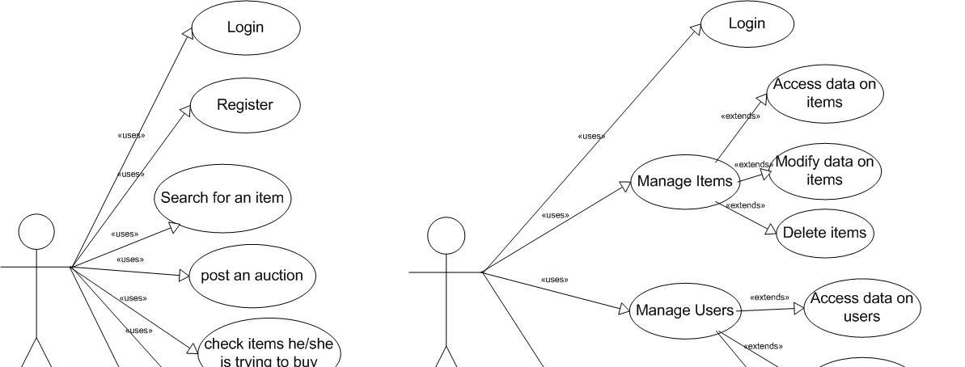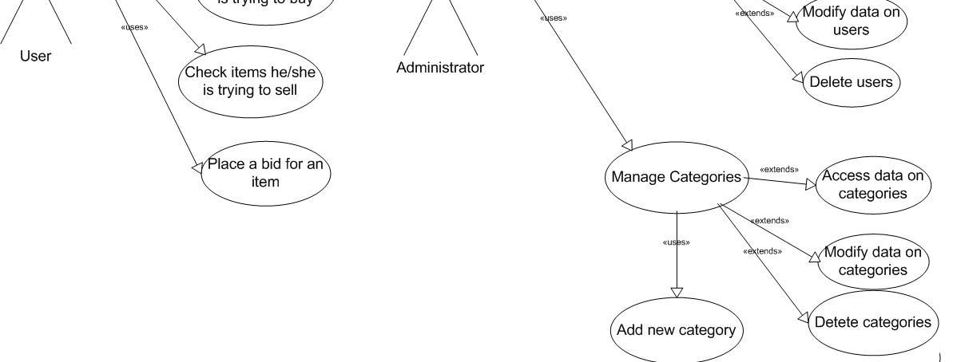

**3.2 User Stories**

After collecting all use cases, user stories can be written. A user story “is the smallest

amount of information (a step) necessary to allow the customer to define (and steer) a

path through the system” [8].

The user stories are divided into 2 main categories: user side (stories for the general

users) and administration side (the stories for the administrators of the system).

User Side Stories:

*Home Page:*

The home page is the entry point to access the main services:

• Register

• My personal page

• Search

• Help

The home page shows also a list of categories to simplify items searching and the latest

auctions.

*Registration:*

The registration page allows user to provide his/her personal data (name, address, date of

birth, fiscal code, email address, phone number, userID, password) and receive a userID

and a password. UserID and password allow the user to access to his/her personal page,

to take part to the auction and to post a new auction.

It performs basic checks on entered data and provides user registration or an error

message if the userID and/or user fiscal code are already present in the system.

*Login*

Every time the user tries to access to non-public areas (personal page, bid, post an

auction…), he/she is asked to provide his/her personal ID and password. These are

entered through a form. If userID and password are correct, the user is logged in and is no

more asked to login throughout the session. Otherwise an error message is raised.

*Personal page:*

To access the personal page the user is asked to login, or to register. The personal page

keeps track of all the items the user is presently trying to buy and has bought in the recent

past and of all items he/she is trying to sell. From this page it is also possible to post a

new auction.

*Browse:*

The user can browse the auctions selecting among several categories of items (e.g. cars,

books etc.). The results will be shown in a table and the user can sort them by price, by

auction interval (by lasting period of the auction).

11 *Search:*

The user can search for items on auction providing a key word by different criterions:

• Excluding a word

• In a given category

• In a given city

• Auctions having price from a given value in Euro to another value

Both registered and unregistered users can access to this service.

*Item page:*

Item characteristics are shown in the item page. From this page the user can place a bid

pushing the button “PLACE A BID” and view the chronology of the bids.

*Bid:*

The user that makes a bid is asked to login if not already logged. If the bid is accepted by

the system, the item is listed in the user personal page. Bids can only be placed during the

auction interval and they must be at least one minimum increment bid above the current

price.

*Post an auction:*

From his/her personal page, the user can post an auction from a specific form, providing

the characteristics of the item he/she is willing to sell. If the auction is accepted by the

system, the item is listed in the user personal page and other users can place a bid for it.

*Help:*

The system must provide help pages in order to explain how to perform all possible

actions, such as registering, searching items, posting an auction etc.

*Change language:*

The user can change from every page the language in which he/she wants to read the

pages with a combo box (Italian/English).

*Chat:*

The user can enter in a chat room using as nickname his/her userID and as password

his/her personal password. In the chat room can send message to all users or send private

messages to only one user.

*Messages:*

The user can send message to other users with a text and a topic and the message will be

sent via email to the receiver. It is also possible to view the received messages on the

website and answer to them.

12 13

Administrator Side Stories:

*Administrator Page:*

From the login page, providing his/her administratorID and password, he/she can access

the administrator page, that shows the administrator menu to access all the administration

activities (manage items, manage users, manage categories).

*Manage Items:*

The administrator can access all data about items stored in the database and also delete

them, but not modify the characteristics of the items (initial price, description etc.).

*Manage Users:*

The administrator can access and modify all data about users stored in the database and

also delete them.

*Manage Categories:*

The administrator can access and modify all data about categories stored in the database,

add a new category and also delete them. The administrator can delete a category if and

only if no items are associated to that category; otherwise an error message is raised.

*Accept / refuse auction:*

The administrator can control the new auctions posted by the user and decide whether to

accept or to refuse them.

* + 1. **Non-functional requirement**

**Interactive and good performance**

The website for online auction system shall have the following abilities and capabilities.

* Responsiveness of the website shall be high and the website shall behave as per the user action.
* The reponse time and throughput time on the site shall be minimal.
* Consistency on the website shall be maintained across all the webpages
* The user shall be acknowledged in the form of visual changes and feedback on the site to enhance the interaction.
  1. **Design**
     1. **low-level design**

**Authentication Module**

Authentication module is the module where the user gets authenticated. Authentication is otherwise known as validation. In this

module the buyer/seller first gets registered in order to proceed further. Buyer and seller have separate authentication procedure.

If the provided information does not meet the criteria, the user is not validated.

**Architecture diagram**

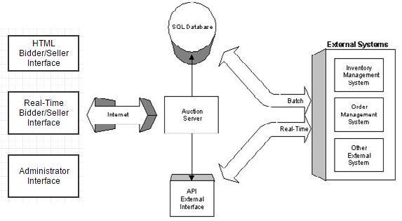

**Authentication module**

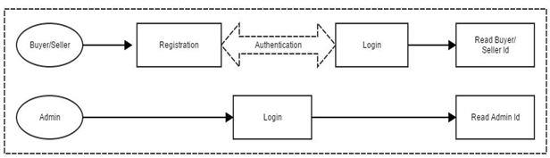

**Buyer Module**

In this module buyer can visit the site. In order to apply the bid the buyer has to login to the system and must buy bid points in

order to bid the product. If the buyer wishes to buy the product he can apply the bid. If the bid is unique and large the buyer will

get the product. When the buyer won the product he has to make payment to the system.

**Buyer module figure**

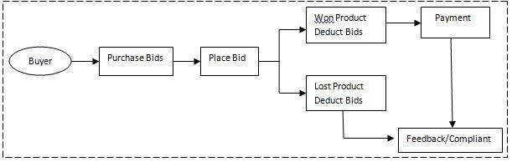

**Seller Module**

In this module seller has to login to the system and register his product to the system for auction. When the auction is completed

administrator informs the details of buyer so that seller handover the product to the system. Seller receives the payment from the

system.

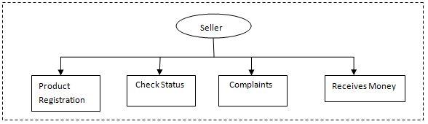

**Administrator Module**

Admin module does all the task that enables the user to bid for an item effortlessly. Admin will create and update the

categories. Under the categories we can find different items that are up for the auction. Admin will take care of all the

information regarding the items under each category. Admin will be responsible for all the actions done by the users. Admin

can block the users and can change privileges of the selected user. Admin can delete the categories and can delete the

items that are up for the auction. Administrator is responsible for the inventory maintenance.

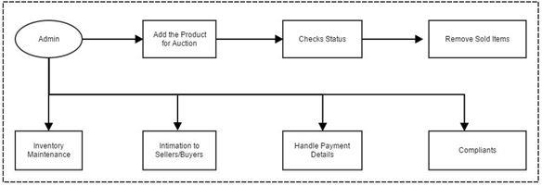

* + 1. **High-level design**

**Page Flow Diagram**

Since the on line auction portal consists of web pages, it is useful to draw a page flow

diagram. A page flow is a diagram that visually organizes the flow and actions of the web

pages [9]. Here is the page flow that represents the path, for a normal user, to register to

the system, search for an item and place a bid and make a logon.

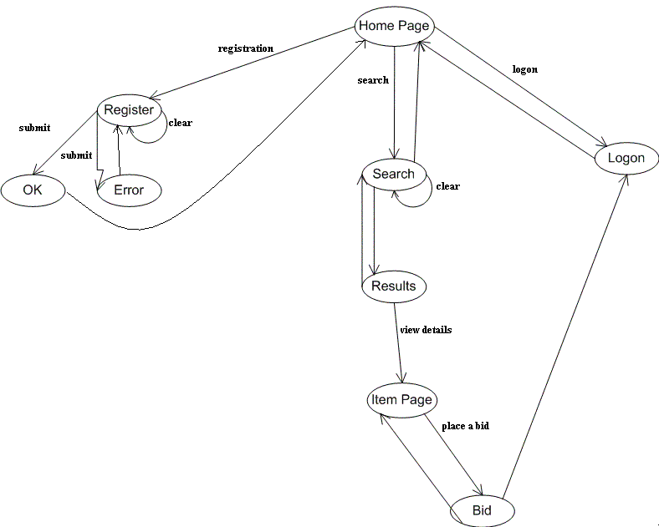

**Final page**

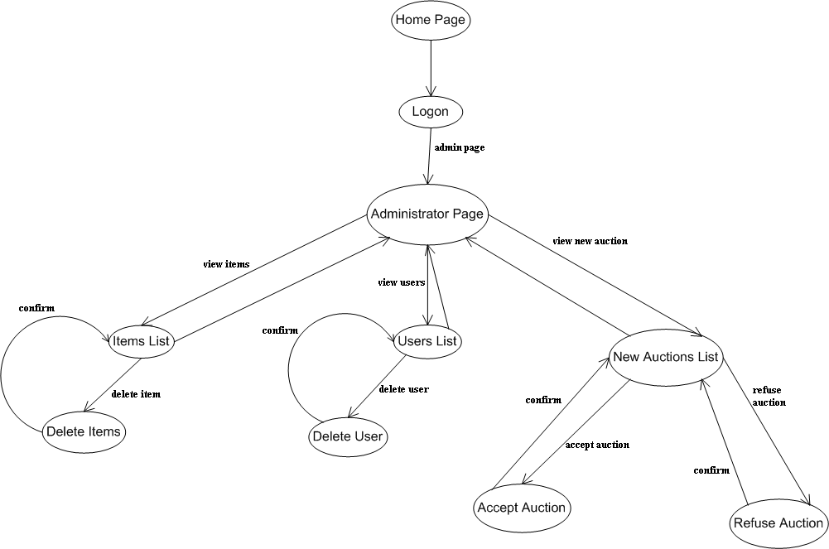

1. **r diagram**

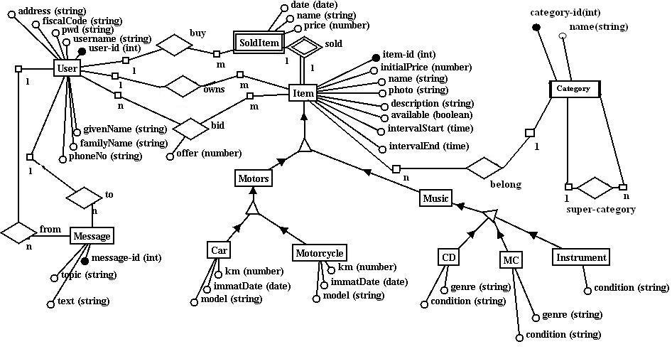

**Results**

The existing system has no option for selling their own product in auction and traditional method is time

consuming process where date and time plays an important role, as they operate for couple of hours. To overcome

this, system creates a way for sellers to upload their product for auction. There are no time constraints in this

system like traditional one. Buyers who are applying bid can be monitored by the administrator. Buyer can place

more than one bid at a time for multiple products. By this system we can overcome the problems of Bid Shielding

and shill bidding. Buyer can easily compare the bid which is applied for a particular product.

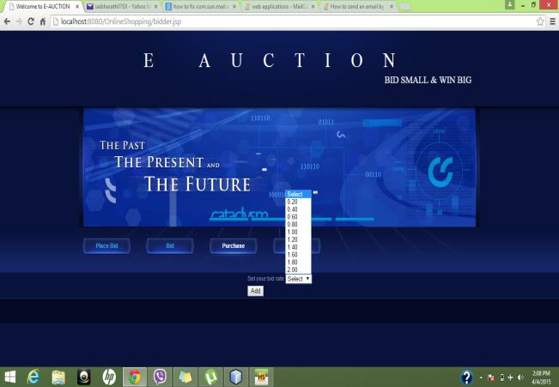

* 1. **Implementation development**
  2. **Testing**

**Follow Sellers.** When bidders choose to follow a seller, they’re automatically notified when the seller

lists items and can easily view the seller’s other ongoing auctions.

**Keyword Alerts.** When bidders input keywords, they’re automatically notified when items matching

keywords are posted are listed.

**Auction Watch List.** Municibid enables bidders to add items to their Watch List with ease. Once they

do, they receive auction updates until the auction ends.

**Alerts and notifications**

provides a variety of alerts and notifications to ensure that bidders stay engaged and

informed.

**Alerts and keywords**

system Auction Alerts help us ensure that bidders never miss another deal and that an agency’s auctions receive the greatest number of bids possible

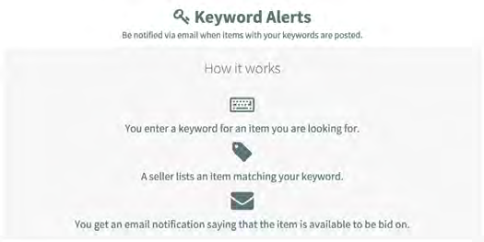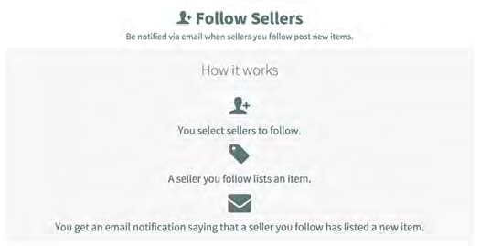

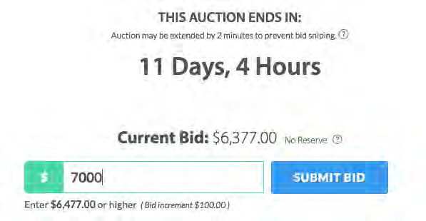

**CHAPTER FOUR: CONCLUSION AND RECOMMENDATIONS**

**4.1** **conclusion**

Online auction is a system where we participate in a bid for products and service. This auction is made easier by

using online software which can regulate processes involved. There are several different auction methods or types

and one of the most popular methods is English auction system. This system has been designed to be highly

scalable and capable of supporting large numbers of buyers and sellers in an active auction.

**4.2 recommendations**

The online auction portal works very well in all of its functionality. However, some

future works can be done on the existing system:

• Add an SSL security system. Since a registered user can post new auctions, place

bids, send messages etc., username and password are sensible data. So it could be

useful to protect these data from being intercepted by a third party.

• Add a chat room to the portal. It would be nice for a user to enter in a chat room

to talk with other users about auctions or any other topic. This chat can be realized

using the Java Applet technology.

• Add a more attractive graphics to the web pages of the portal. The site is very

easy to browse, also for new users, because the pages are simple and clear.

However, the graphics of the site is also much simple, so it could be the case to

improve it in order to attract more users. 29

• Add a credit card payment system. It would be nice for users to make payments

using their own credit card to exchange money with the help of the website.

**CHAPTER FIVE: REFERENCES**

**References**

[1] Albert, M. R. (2002). "E-Buyer Beware: Why Online Auction Fraud Should Be Regulated". American

BusinessLawJournal 39 (4):575. Doi:10.1111/j.1744-

1714.2002.tb00306.x

[2] Ravi Bapna, R.; Goes, P.; Gupta, A. (2001). "Insights and analyses of online auctions”. Communications of the

ACM 44 (11): 42. Doi: 10.1145/384150.384160.

[3] Vakrat, Y.; Sideman, A. (2000). "Implications of the bidders' arrival process on the design of online auctions". Proceedings

of the 33rd Annual Hawaii International Conference on System Sciences.

p. 7. Doi:10.1109/HICSS.2000.926822. ISBN 0-7695-0493-

0..

[4] Milgrom, P.; Weber, R. (1982)."A theory of auctions andcompetitivebidding".Econometrica 50 (5):10891122. Doi:

10.2307/1911865. JSTOR 1911865.

[5] Pinker, E. J.; Sideman, A.; Vakrat, Y. (2003). "Managing Online Auctions: Current Business and Research

Issues". Management Science 49 (11):

1457.Doi:10.1287/mnsc.49.11.1457.20584

[6] Simone Pigolotti, Sebastian Bernhard son, Jeppe Juul, Gorm Galster, Pierpaolo Vivo (2012). "Equilibrium strategy and

population-size effects in lowest unique bid auctions".

Retrieved 2012-10-25.

[7] Atwood, Jeff (2009-05-25). "Penny Auctions: They're Gambling". Coding Horror. Retrieved 2013-01-03.

[8] "Is Swoop Nothing More Than a Well-Designed Gimmick?".

Technologizer.com. 2008-09-17. Retrieved 2013-01-03.

[9] "Auction Scams". OnlineAuctionReviews.org